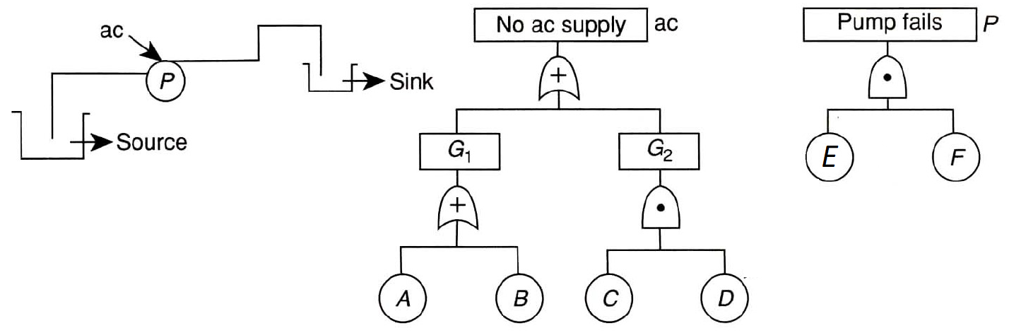

The pumping system shown above allows water to be transferred from the source to the sink. The pumping system requires both the AC supply AND the Pump P to work for the water to be transferred.

The fault trees for ‘no ac supply’ and ‘pump fails’ are shown.

Assuming A, B, C, D, E and F are all independent and rare events, on a given year, the probability of each event is 0.1 [that is P(A)=P(B)=P(C)=P(D)=P(E)=P(F)=0.1].

Calculate the following:

Probability of ‘no ac supply’: P(A)+P(B)+[P(C).P(D)]=0.1+0.1+(0.1\*0.1)=0.21

Probability of ‘pump fails’: P(E).P(F)=0.01

Probability of the pump system to be working = [1-Pr(‘no ac supply’)].[1-Pr(‘pump fails’)]

=[(1-0.21)\*(1-0.01)]=0.78